FALSE TITLE PRESENTS: WOMENSwear

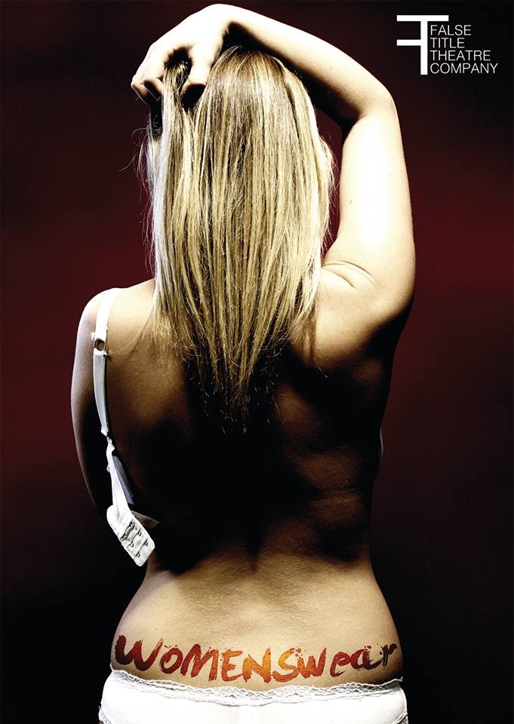
MARKETING PACK

contents

About False Title

About WOMENSwear

Target Audiences / Selling Points / Box Office Information
Brochure Copy
Meet the Company
Our Marketing Tools

about false title

We are a collaboration of three female performance artists.

We redefine and retell, travelling through the unfamiliar.

We create work which explores the intricacies of the spaces in which we live, and the people who shape those environments.

We embed our work in the monotony of the every day, performing the unperformable. We drink coffee, we eat biscuits, we work until the job is done.

We examine life in an ever-changing world, responding spontaneously to the real, the current, the happening.

Our work is a constantly evolving process, focusing on the plurality of contemporary life by breaking the boundaries of the theatrical event.

Through a compilation of music, movement and narrative, we take the small fragments of life and fuse them into performance.

We refine.

We rediscover.

We are False Title.

About Womenswear

N.B Please don’t use this as brochure copy - this is for internal use only.

WOMENSwear is a piece of verbatim theatre about women, historically, internationally and in our own familiar westernised world. It is about how they are perceived, and their roles within vastly different cultures; through real stories taken from interviews, speeches and our own experiences as a company, we explore what it is to be a woman in a constantly changing world.

Performed by the three female members of the company, the story comes to life within a framework of music, movement and narrative, weaving intricate tales together and constructing a three-dimensional, fully formed look into the lives of women.

We have gathered stories from mothers, daughters, sisters and grandmothers, women of all ages and all backgrounds, women who want a voice. They are set in the westernised world, internationally and in history- WOMENSwear switches between time frames, locations and cultures, telling stories that are united through the manifestation of women’s roles.

Through the use of two platforms and exposed scaffolding, juxtaposed with the creation of familiarity and bleakness in the form of defined stage spaces, we immerse ourselves in the set and in the story. We represent and provoke both new and old ways of thinking about women.

Target audiences

WOMENSwear will appeal to:

- Audiences who like the work of artists/ companies such as Kate Tempest, Out of Joint, Forced Entertainment, Complicite, Paines Plough, Wunderbaum.
- Audiences who are interested in the roles of women in different cultures.
- Audiences who are interested in set design and its relationship to performance.
- Students studying drama/ theatre, especially those interested in contemporary performance, set design and verbatim theatre.

selling points

- A unique view into the lives of women both in international and westernised cultures, extending that study in the form of verbatim, music and movement sequences.
- A immersive experience, heightened by a set which lives and breathes as we tell the story. It is a compelling and thought provoking piece.

Box office information

Company Name: False Title Running Time: 45 mins (no interval)
Show Name: WOMENSwear Age Guidance: 12+

Brochure Copy

In your own words, how would you define the term ‘woman’?
Respondent skipped this question.

In your own words, what do you think the role of a woman is?
Respondent skipped this question.

We cry. We bitch. We moan. We seduce. We give birth. We wear bras. We buy shoes. We menstruate. We cook dinner. We clean dishes. We wash clothes. We pick arguments. We know what we want. We are attention seekers. We are the emotional sex.

We go to work. We dress as we please. We love. We laugh. We desire.

Taken from interviews, speeches and historical events, WOMENSwear explores the perceptions and realities of womanhood embedded into society.

Meet the company

Samantha Thomas (writer, director and performer) Samantha has performed in a number of productions during her BA Hons in Drama at the University of Lincoln.

In 2013, she undertook the role of Ophelia in William Shakespeare’s Hamlet, while directing an excerpt of Charlotte Keatley’s My Mother Said I Never Should. In 2014, Samantha spent time with a group of artists to produce The Curators; a durational site-specific performance in the University of Lincoln Great Central Warehouse Library. During this time, she also spent time on placement at Lincoln Performing Arts Centre as a Marketing Support Officer.

Alongside her university degree, Samantha performed in The Lincoln Company production of Shoot, Get Treasure, Repeat at Lincoln Performing Arts Centre in 2013. She has also performed with the company in A Modernist Event for the Edinburgh Festival Fringe 2014 programme, while assistant stage managing Shane Humberstone’s First World Problems.

Lauren Brook (marketing manager, sound composer and performer) Lauren has a wide body of marketing and performance work, contained within the Lincoln Performing Arts Centre where she has studied drama for three years.

In 2013, Lauren performed at the National Theatre as part of the National Connections Festival with the Lincoln Young Company, which saw her play Harley in Stacey Gregg’s I’m Spilling My Heart Out Here. Since then, she has taken a step back from performing, choosing instead to focus on marketing and stage management roles.

She has been the stage manager for the Lincoln Young Company for the past two productions, and has taken an active role in the programming of the venue through LPAC Producers, with whom she has produced and commissioned artists such as Sara Pascoe and Sam Halmarack. She has been the marketing manager of the group since September 2014.

Holly Hutchinson (stage manager, producer and performer) Holly has taken on a large number of roles within her degree performance work, helping to create and present many productions in conjunction with other students.

Most notably, Holly stage managed Hamlet in 2013 whilst also performing in the role of Bernardo. She has also been involved in smaller student shows, including Cross-Over Live due to be performed in May 2015, and a series of site-specific durational pieces based in the Lincoln Performing Arts Centre building.

Through working in retail, Holly has discovered a passion for management, and this has transcended into her work as a stage manager within the theatre.

Tools available

False Title Blog: www.falsetitle.blogs.lincoln.ac.uk

False Title Twitter: www.twitter.com/FalseTitleTC (@FalseTitleTC)

False Title Facebook Page: www.facebook.com/falsetitletc

False Title Youtube Channel (playlists of videos which inspired the process) www.youtube.com/channel/UCzeend_GLgjbrTAZsWTszqg

Sound Composer’s Youtube Channel (songs which inspired the process/ are in the show) www.youtube.com/channel/UCZYYeIIJ1niK0UkM-QOU0IA/feed

